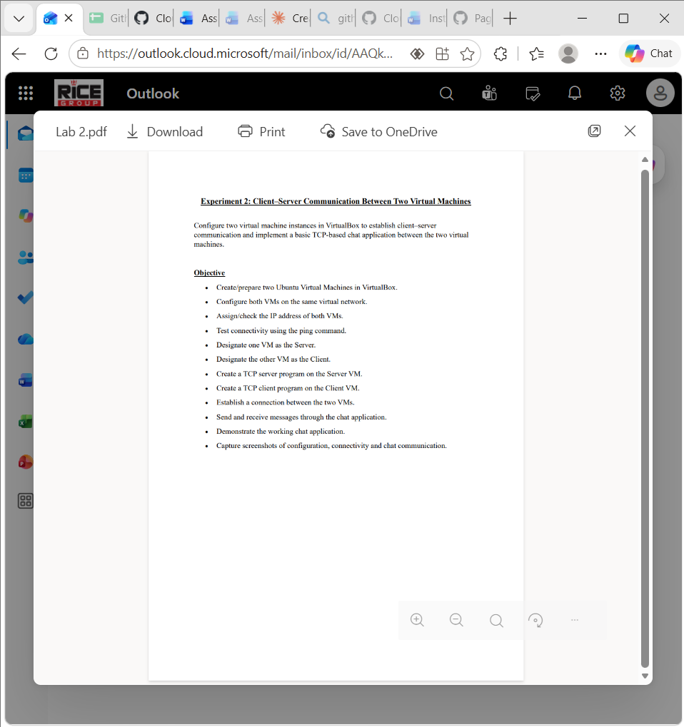

- Creating and preparing two Ubuntu Virtual Machines in Virtualbox.
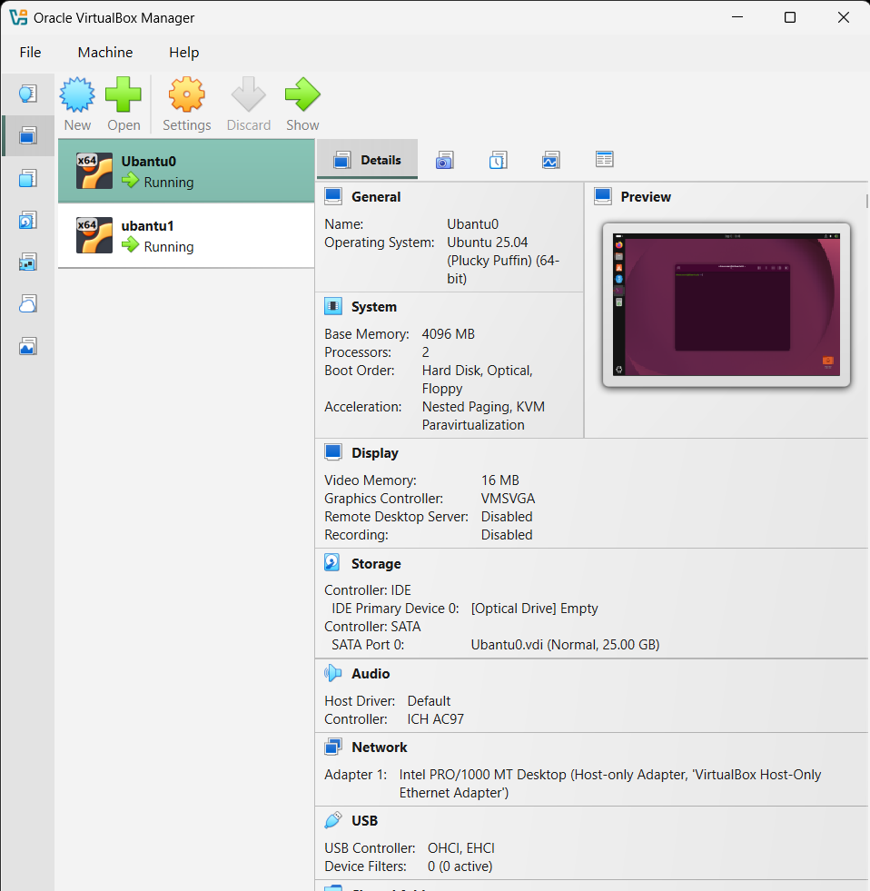

- Configure both VMs on the same virtual network
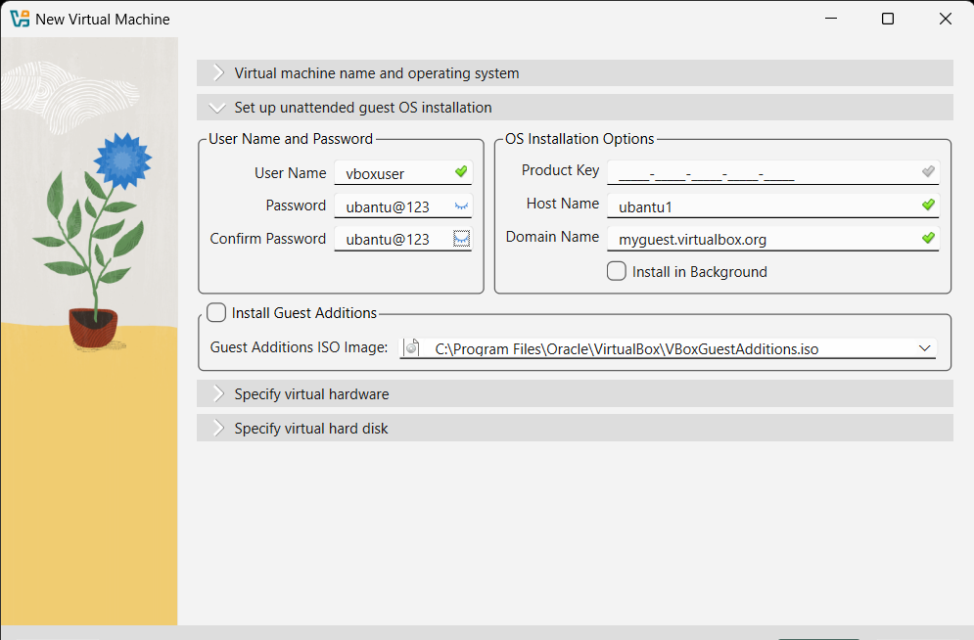

- Checking the IP address of both VMs.
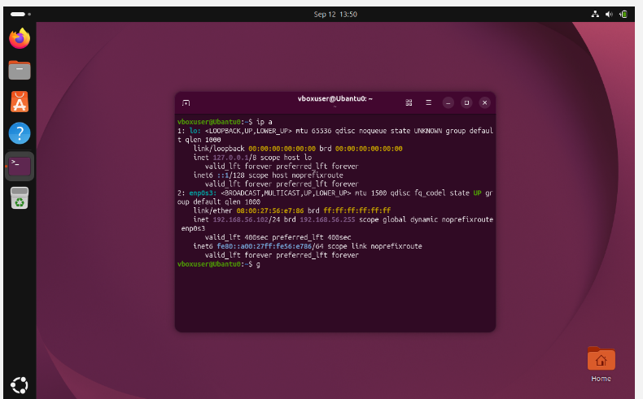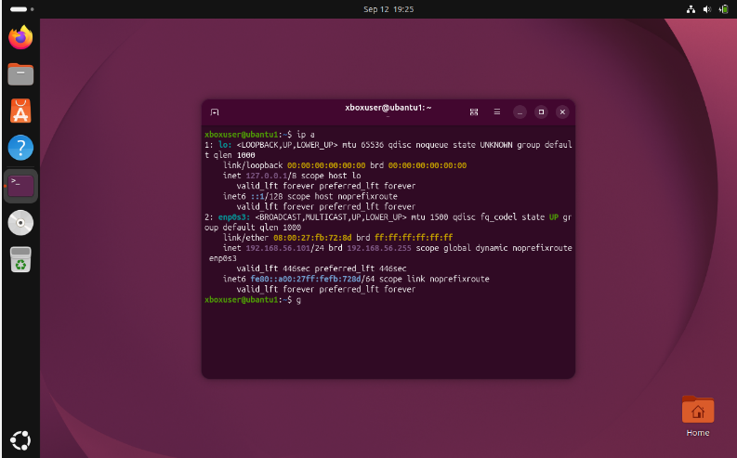

- Testing connectivity using the ping command
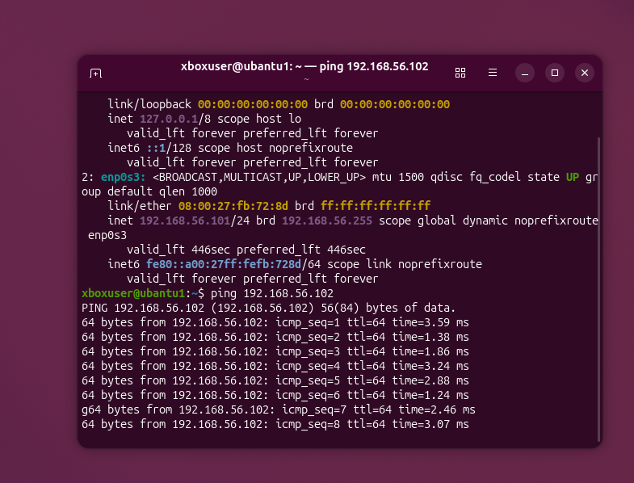

- Designate one VM as the Server.
- Designate the other VM as the client
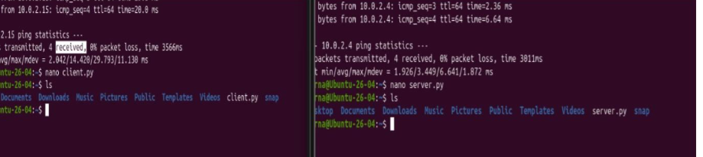

- Create a TCP server program on the Server VM
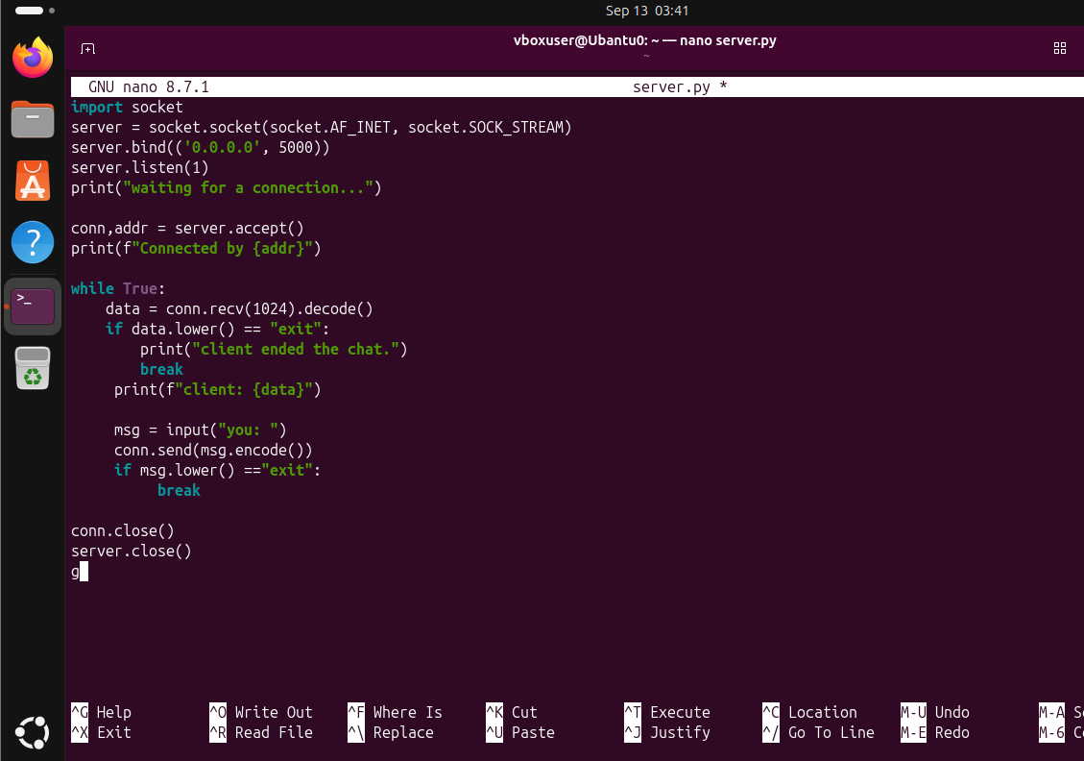

- Create a TCP client program on the Client VM
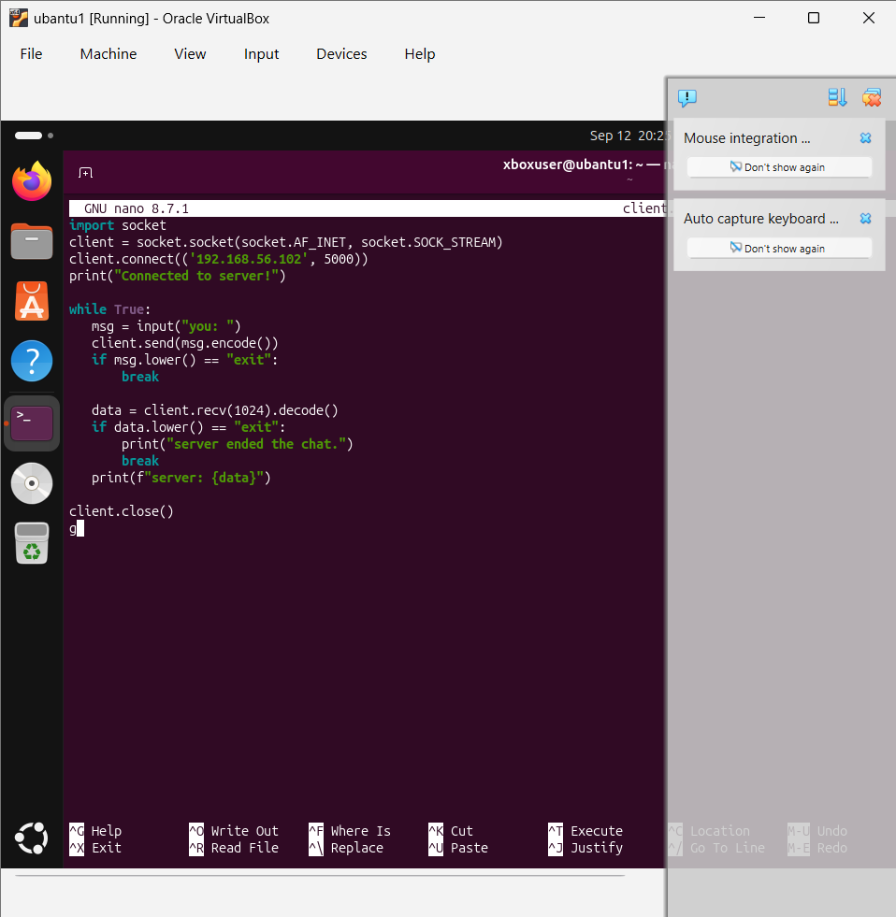

- Establishing a connection between the two VMs.
- Sending and receiving messages through the chat application.
